**ARTIFICIAL INTELLIGENCE**

(CA 3)

**PROJECT**

**QUIZ**

**MODULE**

**SUBMITTED TO:**

SHABNAM MAM

**SUBMITTED BY:**

ROLL NO. 21 MASIPEDDI.SAIKIRAN (11808401)

ROLL NO. 13 J.ASHISH PATEL (11808399)

ROLL NO. 14 E.SAIKIRAN (11808405)

ROLL NO. 09 P.SAI SANDEEP REDDY (11808866)

# **Githublink:**<https://github.com/saikiran8885>/**[AI-project-quiz-application](https://github.com/saikiran8885/AI-project-quiz-application)**

**ABOUT PROJECT:**

The main intention in the implementation of our project is to design the quiz module that consists of the three levels of easy level, medium level, and tough level and had written ten questions in one level. We had assigned the 10 variables for defining ten different questions and this module displays the entirely the three different windows in which the first window shall take the input from the user and responds according to the level he selects.

These modules take the user input and responds to him take the optional values as per the user and collects the information and increments the value of the score and finally the last value of the score get printed in the dialogue box. Here the user name gets printed at the starting position in every module as a welcome message. In the evaluation of the efficiency of the writer we had divided the quiz into the three categories in which it contains the easy, average, tough levels.

And in the executing process it entirely based on the code compiler (Pycharm) here we used the labels, radio buttons, button tags, labels that contain the text that we had entered. Each and every question in the quiz has four options indicated by the values a, b, c, d and at last the submit button and the result button that displays the result on the display screen.

**MODULES:**

The system comprises of 1 major module with their sub-modules as follows:

1. **User:**

* **Login:** user can login using credentials
* **Homepage:** user can view the webpage
* **Quiz Details:** user can see the quiz details
* **Level Details:** user can choose the levels of quiz.
* **attempt:** user can attempt the questions.

1. **Diagram:**

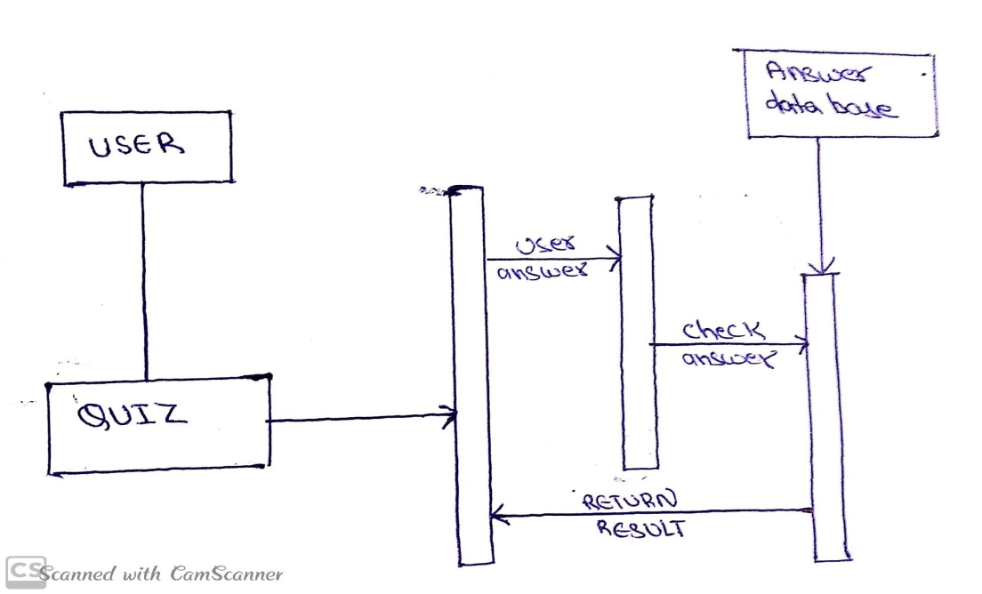

The working scenario of our project is as shown above.

**ALGORITHM:**

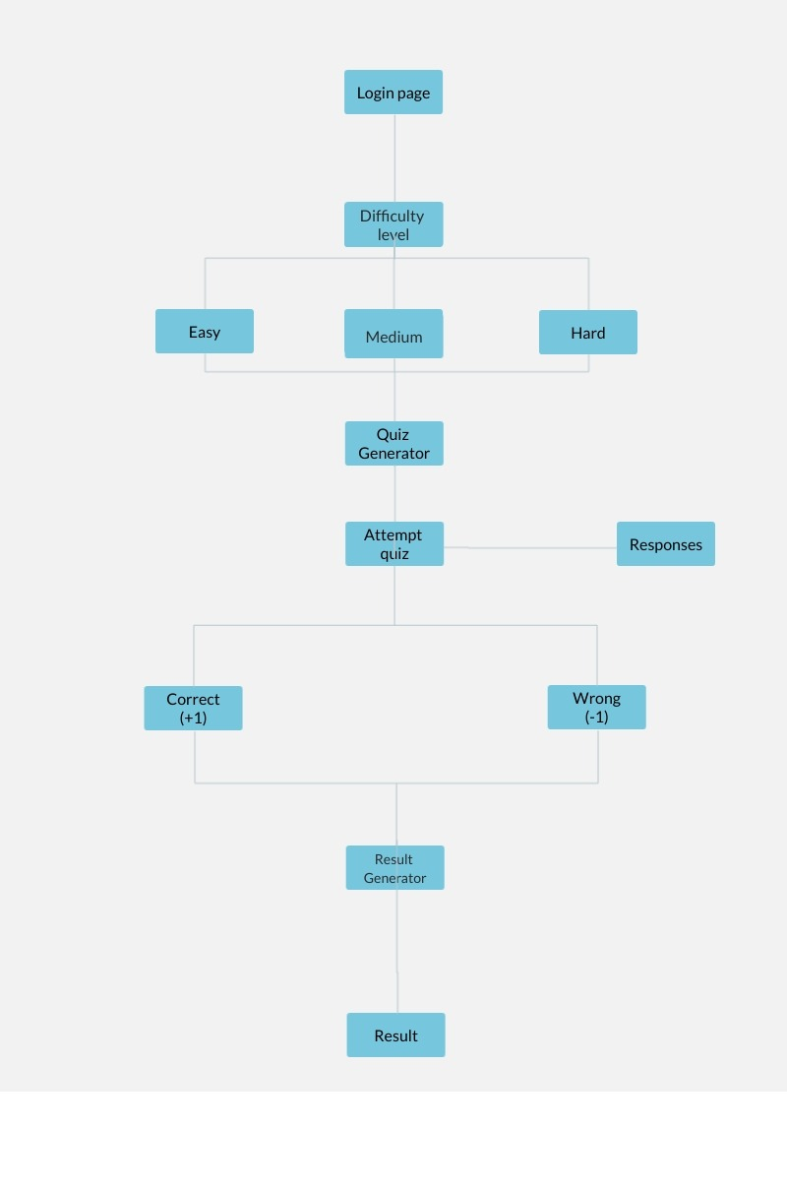

* **Hardware Requirement:**
* i3 Processor Based Computer or higher
* Memory: 4 GB
* Hard Drive: 64 GB
* Monitor
* Internet Connection
* **Software Requirement:**
* Windows 7 or higher
* Phython 3.6 shell
* Anaconda software

**CODE EXECUTION IN PYTHON 3.6.7**

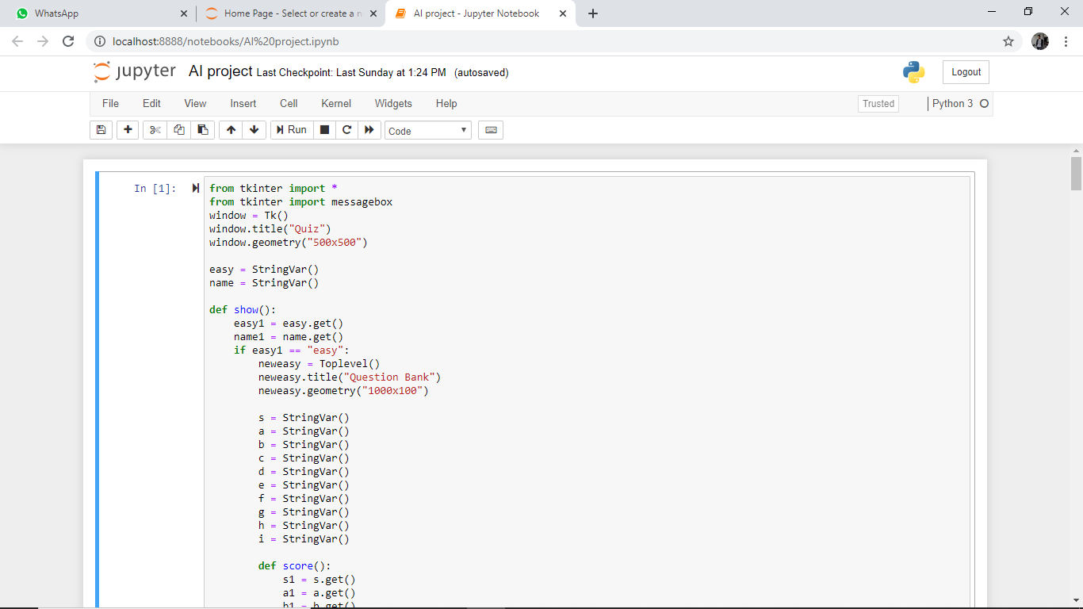

**QUIZ CODE**

from tkinter import *

from tkinter import messagebox

window = Tk()

window.title("Quiz")

window.geometry("500x500")

easy = StringVar()

name = StringVar()

def show():

easy1 = easy.get()

name1 = name.get()

if easy1 == "easy":

neweasy = Toplevel()

neweasy.title("Question Bank")

neweasy.geometry("1000x100")

s = StringVar()

a = StringVar()

b = StringVar()

c = StringVar()

d = StringVar()

e = StringVar()

f = StringVar()

g = StringVar()

h = StringVar()

i = StringVar()

def score():

s1 = s.get()

a1 = a.get()

b1 = b.get()

c1 = c.get()

d1 = d.get()

e1 = e.get()

f1 = f.get()

g1 = g.get()

h1 = h.get()

i1 = i.get()

count = 0

if s1== "b":

count+=1

if a1== "c":

count+=1

if b1 == "d":

count += 1

if c1 == "c":

count += 1

if d1 == "c":

count += 1

if e1 == "d":

count += 1

if f1 == "c":

count += 1

if g1 == "b":

count += 1

if h1 == "c":

count += 1

if i1 == "a":

count += 1

messagebox.showinfo("Result",count)

label0 = Label(neweasy, text="Welcome " + name1, font=(15)).place(x=50, y=30)

label1 = Label(neweasy, text="Question1 Suppose t = (1, 2, 4, 3), which of the following is incorrect? ", font=(12)).place(x=40, y=80)

radio0 = Radiobutton(neweasy, text=" print(t[3])", value="a",variable=s, font =(9)).place(x=120, y=120)

radio1 = Radiobutton(neweasy, text="t[3]=45",value="b", variable=s, font=(9)).place(x=120, y=150)

radio2 = Radiobutton(neweasy, text="print(max(t))",value="c",variable=s, font=(9)).place(x=290, y=125)

radio3 = Radiobutton(neweasy, text="print(len(t))",value="d", variable=s,font=(9)).place(x=290, y=155)

label1 = Label(neweasy, text="Question2 which of the following is the tuple ", font=(12)).place(x=40,y=190)

radio4 = Radiobutton(neweasy, text=" [1, 2, 3]", value="a", variable=a, font=(9)).place(x=120, y=230)

radio5 = Radiobutton(neweasy, text="(1, 2, 3)", value="b", variable=a, font=(9)).place(x=120, y=260)

radio6 = Radiobutton(neweasy, text="{1, 2, 3}", value="c", variable=a, font=(9)).place(x=290, y=235)

radio7 = Radiobutton(neweasy, text="{}", value="d", variable=a, font=(9)).place(x=290, y=265)

label8 = Label(neweasy, text="Question3 What will be the output of the following Python code? ", font=(12)).place(x=40,y=300)

radio9 = Radiobutton(neweasy, text=" (1,2)", value="a", variable=b, font=(9)).place(x=120, y=330)

radio11 = Radiobutton(neweasy, text="(1, 2, 4)", value="b", variable=b, font=(9)).place(x=120, y=360)

radio12= Radiobutton(neweasy, text="(2,4)", value="c", variable=b, font=(9)).place(x=290, y=335)

radio13 = Radiobutton(neweasy, text="(2,4,3)", value="d", variable=b, font=(9)).place(x=290, y=365)

label14 = Label(neweasy, text="Question4 Which of these about a dictionary is false?", font=(12)).place(x=40,y=400)

radio15 = Radiobutton(neweasy, text="keys", value="a", variable=c, font=(9)).place(x=120, y=430)

radio16 = Radiobutton(neweasy, text="values", value="b", variable=c, font=(9)).place(x=120, y=460)

radio17 = Radiobutton(neweasy, text="ordered", value="c", variable=c, font=(9)).place(x=290, y=435)

radio18 = Radiobutton(neweasy, text="mutable", value="d", variable=c, font=(9)).place(x=290, y=465)

label19 = Label(neweasy, text="Question 5 The function removes the first element.", font=(12)).place(x=40,y=500)

radio20 = Radiobutton(neweasy, text=" remove", value="a", variable=d, font=(9)).place(x=120, y=530)

radio21 = Radiobutton(neweasy, text=" discard", value="b", variable=d, font=(9)).place(x=120, y=560)

radio22 = Radiobutton(neweasy, text="pop", value="c", variable=d, font=(9)).place(x=290, y=535)

radio23 = Radiobutton(neweasy, text=" delete", value="d", variable=d, font=(9)).place(x=290, y=565)

label19 = Label(neweasy, text="Question6 If a={5,6,7,8}, which of the following statements is false? ", font=(12)).place(x=850,y=80)

radio20 = Radiobutton(neweasy, text=" print(len(a))", value="a", variable=e, font=(9)).place(x=930, y=120)

radio21 = Radiobutton(neweasy, text=" print(min(a)", value="b", variable=e, font=(9)).place(x=930, y=150)

radio22 = Radiobutton(neweasy, text="a.remove(5)", value="c", variable=e, font=(9)).place(x=1100, y=125)

radio23 = Radiobutton(neweasy, text="a[2]=45", value="d", variable=e, font=(9)).place(x=1100, y=155)

label19 = Label(neweasy, text="Question7 Only problems that recursively defined be solved using recursion. ", font=(12)).place(x=850,y=190)

radio20 = Radiobutton(neweasy, text=" true", value="a", variable=f, font=(9)).place(x=930, y=230)

radio21 = Radiobutton(neweasy, text="false", value="b", variable=f, font=(9)).place(x=930, y=260)

radio22 = Radiobutton(neweasy, text=" both of the above", value="c", variable=f, font=(9)).place(x=1100, y=235)

radio23 = Radiobutton(neweasy, text=" none of the above", value="d", variable=f, font=(9)).place(x=1100, y=265)

label19 = Label(neweasy, text="Question8 Recursion and iteration are the same programming approach.", font=(12)).place(x=850,y=300)

radio20 = Radiobutton(neweasy, text=" true ", value="a", variable=g, font=(9)).place(x=930, y=330)

radio21 = Radiobutton(neweasy, text=" false", value="b", variable=g, font=(9)).place(x=930, y=360)

radio22 = Radiobutton(neweasy, text=" both", value="c", variable=g, font=(9)).place(x=1100, y=335)

radio23 = Radiobutton(neweasy, text=" none of the above", value="d", variable=g, font=(9)).place(x=1100, y=365)

label19 = Label(neweasy, text = "Question9 Which keyword is used for function ", font=(12)).place(x=850,

y=400)

radio20 = Radiobutton(neweasy, text=" fun", value="a", variable=h, font=(9)).place(x=930, y=430)

radio21 = Radiobutton(neweasy, text=" define ", value="b", variable=h, font=(9)).place(x=930, y=460)

radio22 = Radiobutton(neweasy, text=" function", value="c", variable=h, font=(9)).place(x=1100, y=435)

radio23 = Radiobutton(neweasy, text="definition", value="d", variable=h, font=(9)).place(x=1100, y=465)

label19 = Label(neweasy, text= "Question10 Which of the following functions is a built-in function in python? ", font=(12)).place(x=850,y=500)

radio20 = Radiobutton(neweasy, text=" sqrt()", value="a", variable=i, font=(9)).place(x=930, y=530)

radio21 = Radiobutton(neweasy, text=" seed() ", value="b", variable=i, font=(9)).place(x=930, y=560)

radio22 = Radiobutton(neweasy, text=" factorial()", value="c", variable=i, font=(9)).place(x=1100, y=535)

radio23 = Radiobutton(neweasy, text=" print()", value="d", variable=i, font=(9)).place(x=1100, y=565)

button2 = Button(neweasy, text="SUBMIT", font=(15), bg="skyblue", fg="black", command=score).place(x=1150, y=700)

button2 = Button(neweasy, text="Result", font=(15), bg="skyblue", fg="black").place(x=1400, y=700)

elif easy1 == "medium":

neweasy = Toplevel()

neweasy.title("Question Bank")

neweasy.geometry("1000x100")

s = StringVar()

a = StringVar()

b = StringVar()

c = StringVar()

d = StringVar()

e = StringVar()

f = StringVar()

g = StringVar()

h = StringVar()

i = StringVar()

def score():

s1 = s.get()

a1 = a.get()

b1 = b.get()

c1 = c.get()

d1 = d.get()

e1 = e.get()

f1 = f.get()

g1 = g.get()

h1 = h.get()

i1 = i.get()

count = 0

if s1 == "b":

count += 1

if a1 == "c":

count += 1

if b1 == "d":

count += 1

if c1 == "c":

count += 1

if d1 == "c":

count += 1

if e1 == "d":

count += 1

if f1 == "c":

count += 1

if g1 == "b":

count += 1

if h1 == "c":

count += 1

if i1 == "a":

count += 1

messagebox.showinfo("Result", count)

label0 = Label(neweasy, text="Welcome " + name1, font=(15)).place(x=50, y=30)

label1 = Label(neweasy, text="Question1 Which of the following commands will create a list? ",

font=(12)).place(x=40, y=80)

radio0 = Radiobutton(neweasy, text=" list1 = list()", value="a", variable=s, font=(9)).place(x=120, y=120)

radio1 = Radiobutton(neweasy, text="list[]", value="b", variable=s, font=(9)).place(x=120, y=150)

radio2 = Radiobutton(neweasy, text="list1 = list([1, 2, 3])", value="c", variable=s, font=(9)).place(x=290, y=125)

radio3 = Radiobutton(neweasy, text=" all of the mentioned", value="d", variable=s, font=(9)).place(x=290, y=155)

label1 = Label(neweasy, text="Question2 What is the output when we execute list(“hello”)? ", font=(12)).place(x=40, y=190)

radio4 = Radiobutton(neweasy, text=" [‘h’, ‘e’, ‘l’, ‘l’, ‘o’]", value="a", variable=a, font=(9)).place(x=120, y=230)

radio5 = Radiobutton(neweasy, text="[‘hello’]", value="b", variable=a, font=(9)).place(x=120, y=260)

radio6 = Radiobutton(neweasy, text=" [‘llo’]", value="c", variable=a, font=(9)).place(x=290, y=235)

radio7 = Radiobutton(neweasy, text=" [‘olleh’]", value="d", variable=a, font=(9)).place(x=290, y=265)

label8 = Label(neweasy, text="Question3 Suppose listExample is [‘h’,’e’,’l’,’l’,’o’], what is len(listExample)? ",font=(12)).place(x=40, y=300)

radio9 = Radiobutton(neweasy, text=" 5 ", value="a", variable=b, font=(9)).place(x=120, y=330)

radio11 = Radiobutton(neweasy, text=" 4 " , value="b", variable=b, font=(9)).place(x=120, y=360)

radio12 = Radiobutton(neweasy, text=" none", value="c", variable=b, font=(9)).place(x=290, y=335)

radio13 = Radiobutton(neweasy, text=" error", value="d", variable=b, font=(9)).place(x=290, y=365)

label14 = Label(neweasy, text="Question4 Suppose list1 is [2445,133,12454,123], what is max(list1)?", font=(12)).place(x=40,

y=400)

radio15 = Radiobutton(neweasy, text=" 2445", value="a", variable=c, font=(9)).place(x=120, y=430)

radio16 = Radiobutton(neweasy, text=" 133", value="b", variable=c, font=(9)).place(x=120, y=460)

radio17 = Radiobutton(neweasy, text=" 12454", value="c", variable=c, font=(9)).place(x=290, y=435)

radio18 = Radiobutton(neweasy, text="123", value="d", variable=c, font=(9)).place(x=290, y=465)

label19 = Label(neweasy, text="Question 5 Suppose list1 is [3, 5, 25, 1, 3], what is min(list1)?", font=(12)).place(x=40,y=500)

radio20 = Radiobutton(neweasy, text=" 3 ", value="a", variable=d, font=(9)).place(x=120, y=530)

radio21 = Radiobutton(neweasy, text=" 5 ", value="b", variable=d, font=(9)).place(x=120, y=560)

radio22 = Radiobutton(neweasy, text=" 25", value="c", variable=d, font=(9)).place(x=290, y=535)

radio23 = Radiobutton(neweasy, text=" 1 ", value="d", variable=d, font=(9)).place(x=290, y=565)

label19 = Label(neweasy, text="Question6 Suppose list1 is [3, 5, 25, 1, 3], what is min(list1)? ",font=(12)).place(x=850, y=80)

radio20 = Radiobutton(neweasy, text=" 1 ", value="a", variable=e, font=(9)).place(x=930, y=120)

radio21 = Radiobutton(neweasy, text=" 5", value="b", variable=e, font=(9)).place(x=930, y=150)

radio22 = Radiobutton(neweasy, text=" 19 ", value="c", variable=e, font=(9)).place(x=1100, y=125)

radio23 = Radiobutton(neweasy, text=" error " , value="d", variable=e, font=(9)).place(x=1100, y=155)

label19 = Label(neweasy, text="Question7 To shuffle the list(say list1) what function do we use?", font=(12)).place(x=850, y=190)

radio20 = Radiobutton(neweasy, text=" list1.shuffle()", value="a", variable=f, font=(9)).place(x=930, y=230)

radio21 = Radiobutton(neweasy, text=" shuffle(list1)", value="b", variable=f, font=(9)).place(x=930, y=260)

radio22 = Radiobutton(neweasy, text=" random.shuffle(list)", value="c", variable=f, font=(9)).place(x=1100, y=235)

radio23 = Radiobutton(neweasy, text=" random.shufflelist(list)", value="d", variable=f, font=(9)).place(x=1100, y=265)

label19 = Label(neweasy, text="Question8 What is the data type of (1)?", font=(12)).place(x=850, y=300)

radio20 = Radiobutton(neweasy, text=" tuple ", value="a", variable=g, font=(9)).place(x=930, y=330)

radio21 = Radiobutton(neweasy, text=" integer", value="b", variable=g, font=(9)).place(x=930, y=360)

radio22 = Radiobutton(neweasy, text=" dictionary", value="c", variable=g, font=(9)).place(x=1100, y=335)

radio23 = Radiobutton(neweasy, text="sets ", value="d", variable=g, font=(9)).place(x=1100, y=365)

label19 = Label(neweasy, text="Question9 If a=(1,2,3,4), a[1:-1] is", font=(12)).place(x=850,

y=400)

radio20 = Radiobutton(neweasy, text=" Error, tuple slicing doesn’t exist", value="a", variable=h, font=(9)).place(x=930, y=430)

radio21 = Radiobutton(neweasy, text=" (2,3)", value="b", variable=h, font=(9)).place(x=930, y=460)

radio22 = Radiobutton(neweasy, text=" (2,3,4)", value="c", variable=h, font=(9)).place(x=1100, y=435)

radio23 = Radiobutton(neweasy, text="[2,3]", value="d", variable=h, font=(9)).place(x=1100, y=465)

label19 = Label(neweasy, text="Question10 What type of data is: a=[(1,1),(2,4),(3,9)]?", font=(12)).place(x=850, y=500)

radio20 = Radiobutton(neweasy, text=" array of tuples", value="a", variable=i, font=(9)).place(x=930, y=530)

radio21 = Radiobutton(neweasy, text=" list of tuples ", value="b", variable=i, font=(9)).place(x=930, y=560)

radio22 = Radiobutton(neweasy, text=" tuples of lists", value="c", variable=i, font=(9)).place(x=1100, y=535)

radio23 = Radiobutton(neweasy, text=" invalid data ", value="d", variable=i, font=(9)).place(x=1100, y=565)

button2 = Button(neweasy, text="SUBMIT", font=(15), bg="skyblue", fg="black", command=score).place(x=1150,

y=700)

button2 = Button(neweasy, text="Result", font=(15), bg="skyblue", fg="black").place(x=1400, y=700)

else:

neweasy = Toplevel()

neweasy.title("Question Bank")

neweasy.geometry("1000x100")

s = StringVar()

a = StringVar()

b = StringVar()

c = StringVar()

d = StringVar()

e = StringVar()

f = StringVar()

g = StringVar()

h = StringVar()

i = StringVar()

def score():

s1 = s.get()

a1 = a.get()

b1 = b.get()

c1 = c.get()

d1 = d.get()

e1 = e.get()

f1 = f.get()

g1 = g.get()

h1 = h.get()

i1 = i.get()

count = 0

if s1 == "b":

count += 1

if a1 == "c":

count += 1

if b1 == "d":

count += 1

if c1 == "c":

count += 1

if d1 == "c":

count += 1

if e1 == "d":

count += 1

if f1 == "c":

count += 1

if g1 == "b":

count += 1

if h1 == "c":

count += 1

if i1 == "a":

count += 1

messagebox.showinfo("Result", count)

label0 = Label(neweasy, text="Welcome " + name1, font=(15)).place(x=50, y=30)

label1 = Label(neweasy, text="Question1 Which of the following statements create a dictionary?",font=(12)).place(x=40, y=80)

radio0 = Radiobutton(neweasy, text=" d={}", value="a", variable=s, font=(9)).place(x=120, y=120)

radio1 = Radiobutton(neweasy, text=" d = {“john”:40, “peter”:45}", value="b", variable=s, font=(9)).place(x=120, y=150)

radio2 = Radiobutton(neweasy, text="d = {“john”:40, “peter”:45}", value="c", variable=s, font=(9)).place(x=290, y=125)

radio3 = Radiobutton(neweasy, text="all of the mentioned ", value="d", variable=s, font=(9)).place(x=290, y=155)

label1 = Label(neweasy, text="Question2 Which of these about a set is not true? ", font=(12)).place(x=40, y=190)

radio4 = Radiobutton(neweasy, text=" mutable data type", value="a", variable=a, font=(9)).place(x=120, y=230)

radio5 = Radiobutton(neweasy, text="allows duplicate vaalues ", value="b", variable=a, font=(9)).place(x=120, y=260)

radio6 = Radiobutton(neweasy, text=" Data type with unordered values", value="c", variable=a, font=(9)).place(x=290, y=235)

radio7 = Radiobutton(neweasy, text=" immutable data type", value="d", variable=a, font=(9)).place(x=290, y=265)

label8 = Label(neweasy, text="Question3 Which of the following is not the correct syntax for creating a set? ",

font=(12)).place(x=40, y=300)

radio9 = Radiobutton(neweasy, text=" set([[1,2],[3,4]])", value="a", variable=b, font=(9)).place(x=120, y=330)

radio11 = Radiobutton(neweasy, text=" set([1,2,2,3,4])", value="b", variable=b, font=(9)).place(x=120, y=360)

radio12 = Radiobutton(neweasy, text="set((1,2,3,4)) ", value="c", variable=b, font=(9)).place(x=290, y=335)

radio13 = Radiobutton(neweasy, text=" {1,2,3,4}", value="d", variable=b, font=(9)).place(x=290, y=365)

label14 = Label(neweasy, text="Question4 What will be the output of the following Python code?", font=(12)).place(x=40,

y=400)

radio15 = Radiobutton(neweasy, text=" 7 ", value="a", variable=c, font=(9)).place(x=120, y=430)

radio16 = Radiobutton(neweasy, text=" error ", value="b", variable=c, font=(9)).place(x=120, y=460)

radio17 = Radiobutton(neweasy, text=" 4 ", value="c", variable=c, font=(9)).place(x=290, y=435)

radio18 = Radiobutton(neweasy, text=" 8 ", value="d", variable=c, font=(9)).place(x=290, y=465)

label19 = Label(neweasy, text="Question 5 Which of the following statements is used to create an empty set?", font=(12)).place(x=40,

y=500)

radio20 = Radiobutton(neweasy, text=" {} ", value="a", variable=d, font=(9)).place(x=120, y=530)

radio21 = Radiobutton(neweasy, text=" set() ", value="b", variable=d, font=(9)).place(x=120, y=560)

radio22 = Radiobutton(neweasy, text=" [ ]", value="c", variable=d, font=(9)).place(x=290, y=535)

radio23 = Radiobutton(neweasy, text=" () ", value="d", variable=d, font=(9)).place(x=290, y=565)

label19 = Label(neweasy, text="Question6 Which of the following statements is used to create an empty set?",

font=(12)).place(x=850, y=80)

radio20 = Radiobutton(neweasy, text=" print(len(a))", value="a", variable=e, font=(9)).place(x=930, y=120)

radio21 = Radiobutton(neweasy, text=" print(min(a)", value="b", variable=e, font=(9)).place(x=930, y=150)

radio22 = Radiobutton(neweasy, text="a.remove(5)", value="c", variable=e, font=(9)).place(x=1100, y=125)

radio23 = Radiobutton(neweasy, text="a[2]=45", value="d", variable=e, font=(9)).place(x=1100, y=155)

label19 = Label(neweasy, text="Question7 What are the two main types of functions? ",

font=(12)).place(x=850, y=190)

radio20 = Radiobutton(neweasy, text=" built in function", value="a", variable=f, font=(9)).place(x=930, y=230)

radio21 = Radiobutton(neweasy, text="system function ", value="b", variable=f, font=(9)).place(x=930, y=260)

radio22 = Radiobutton(neweasy, text=" user function ", value="c", variable=f, font=(9)).place(x=1100, y=235)

radio23 = Radiobutton(neweasy, text=" custom function", value="d", variable=f, font=(9)).place(x=1100, y=265)

label19 = Label(neweasy, text="Question8 Where is function defined?",

font=(12)).place(x=850, y=300)

radio20 = Radiobutton(neweasy, text=" module ", value="a", variable=g, font=(9)).place(x=930, y=330)

radio21 = Radiobutton(neweasy, text=" class", value="b", variable=g, font=(9)).place(x=930, y=360)

radio22 = Radiobutton(neweasy, text=" another function", value="c", variable=g, font=(9)).place(x=1100, y=335)

radio23 = Radiobutton(neweasy, text=" all of the mentioned", value="d", variable=g, font=(9)).place(x=1100, y=365)

label19 = Label(neweasy, text="Question9 What is called when a function is defined inside a class? ", font=(12)).place(x=850,

y=400)

radio20 = Radiobutton(neweasy, text=" module", value="a", variable=h, font=(9)).place(x=930, y=430)

radio21 = Radiobutton(neweasy, text=" class ", value="b", variable=h, font=(9)).place(x=930, y=460)

radio22 = Radiobutton(neweasy, text=" function", value="c", variable=h, font=(9)).place(x=1100, y=435)

radio23 = Radiobutton(neweasy, text=" method", value="d", variable=h, font=(9)).place(x=1100, y=465)

label19 = Label(neweasy, text="Question10 Which of the following refers to mathematical function?",

font=(12)).place(x=850, y=500)

radio20 = Radiobutton(neweasy, text=" sqrt()", value="a", variable=i, font=(9)).place(x=930, y=530)

radio21 = Radiobutton(neweasy, text=" seed() ", value="b", variable=i, font=(9)).place(x=930, y=560)

radio22 = Radiobutton(neweasy, text=" factorial()", value="c", variable=i, font=(9)).place(x=1100, y=535)

radio23 = Radiobutton(neweasy, text=" print()", value="d", variable=i, font=(9)).place(x=1100, y=565)

button2 = Button(neweasy, text="SUBMIT", font=(15), bg="skyblue", fg="black", command=score).place(x=1150,

y=700)

button2 = Button(neweasy, text="Result", font=(15), bg="skyblue", fg="black").place(x=1400, y=700)

label0 = Label(window, text="QUIZ", font=(50), justify=CENTER, width=20, fg="white", bg="black")

label0.place(x=120, y=40)

label1 = Label(window, text="Name: ",font=(15), justify=LEFT).place(x=120, y=100)

entry1 = Entry(window, textvariable=name).place(x=210, y=105)

label2 = Label(window, text="Reg No: ",font=(15), justify=LEFT).place(x=120, y=140)

entry2 = Entry(window).place(x=210, y=145)

label3 = Label(window, text="Section: ",font=(15), justify=LEFT).place(x=120, y=180)

entry3 = Entry(window).place(x=210, y=185)

label4 = Label(window, text = "Level:", font=(15), justify=LEFT).place(x=120, y=220)

radio = Radiobutton(window,text = "Easy",variable = easy, value ="easy", font=(2)).place(x=210,y=220)

radio1 = Radiobutton(window,text = "Moderate",variable = easy, value ="medium", font=(2)).place(x=210,y=250)

radio2 = Radiobutton(window,text = "Tough",variable = easy, value ="hard", font=(2)).place(x=210,y=280)

button1 = Button(window, text="SUBMIT", font=(15), bg="skyblue", fg="black", command = show).place(x=180, y=330)

window.mainloop()

**OUTPUT:**

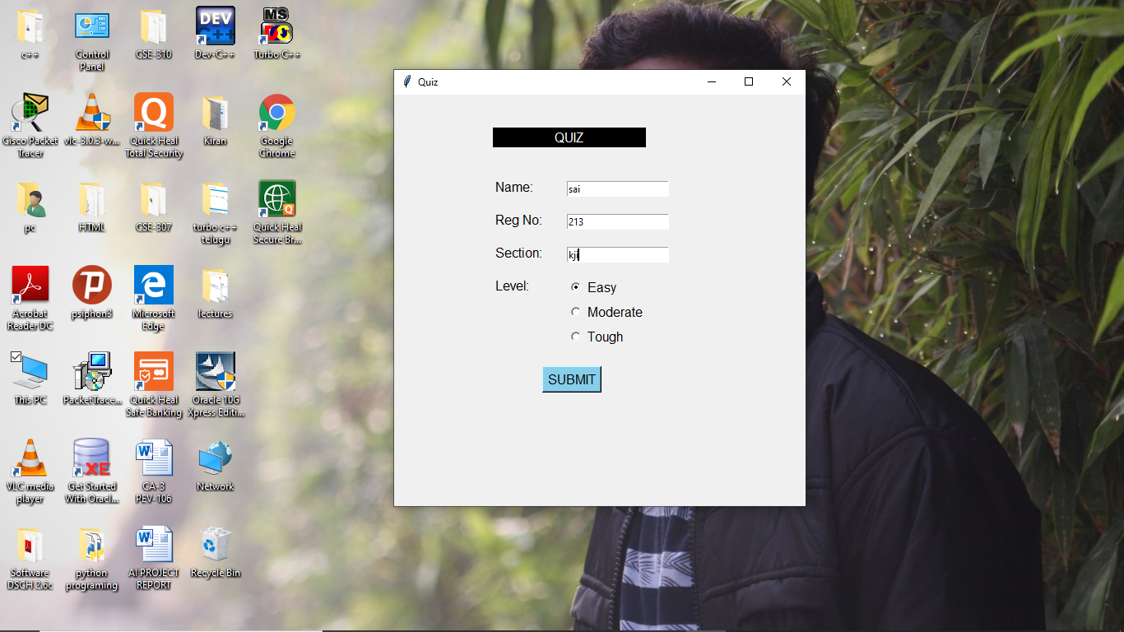

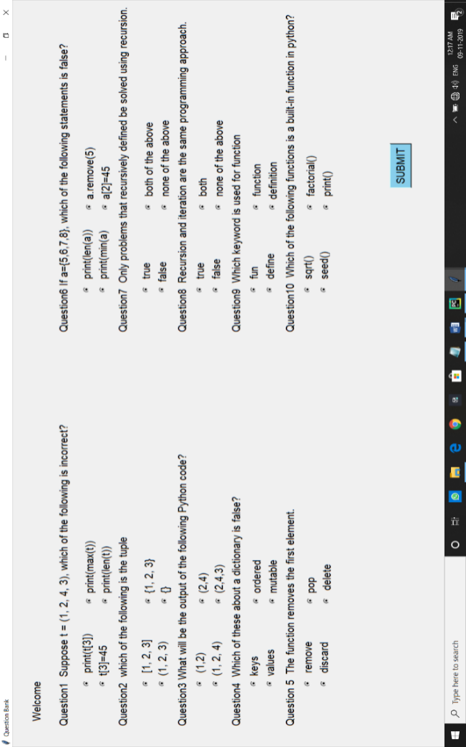This is easy level module which contains 10 questions each contains 4 options and also displays with the welcome message with the name of the user. And also contains the submit button at the end of the test. This module takes the input from the user of his o

This is moderate level which contains 10 questions each contains 4 options and also displays with the welcome message with the name of the user. And also contains the submit button at the end of the test. This module takes the input from the user of his options.

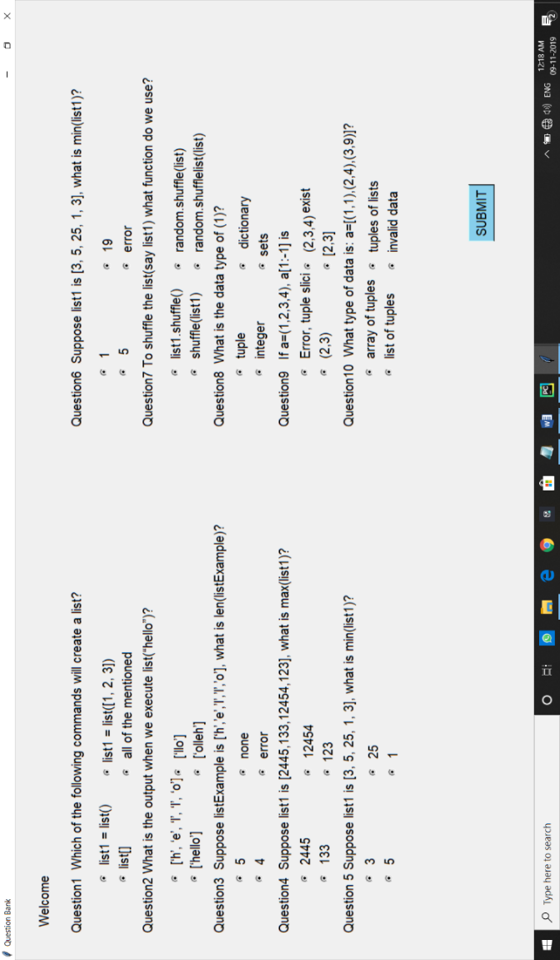

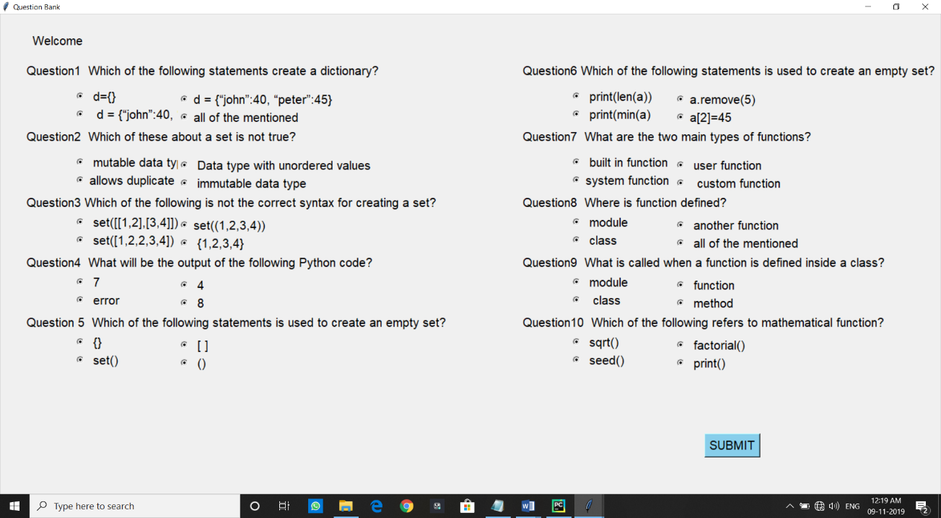

This is tough level which contains 10 questions each contains 4 options and also displays with the welcome message with the name of the user. And also contains the submit button at the end of the test. This module takes the input from the user of his options.

* **Advantages**
* Save time and money
* Generate new knowledge.
* Improves IQ level.
* It provides support to students.
* **Limitation**
* It requires some basic knowledge.
* **Objective**
* Gaining the knowledge about subject and improving IQ.
* **Application**
* This system can be used by the multiple peoples to attempt quiz .
* This application is developed for educational purpose, allowing the users to prepare the multiple choice questions for different examination
* **GRAPHICAL REPRESENTATION:**
* **Pie Chart**
* 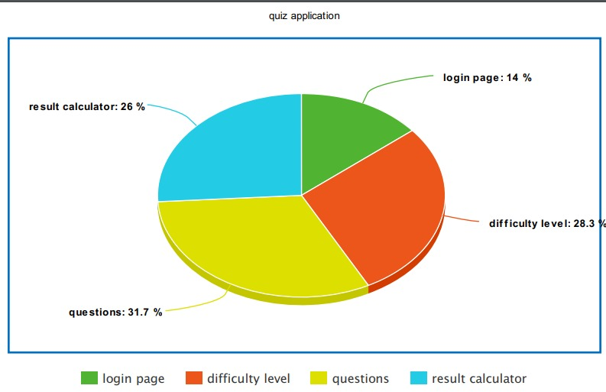

**TEST CASE:**

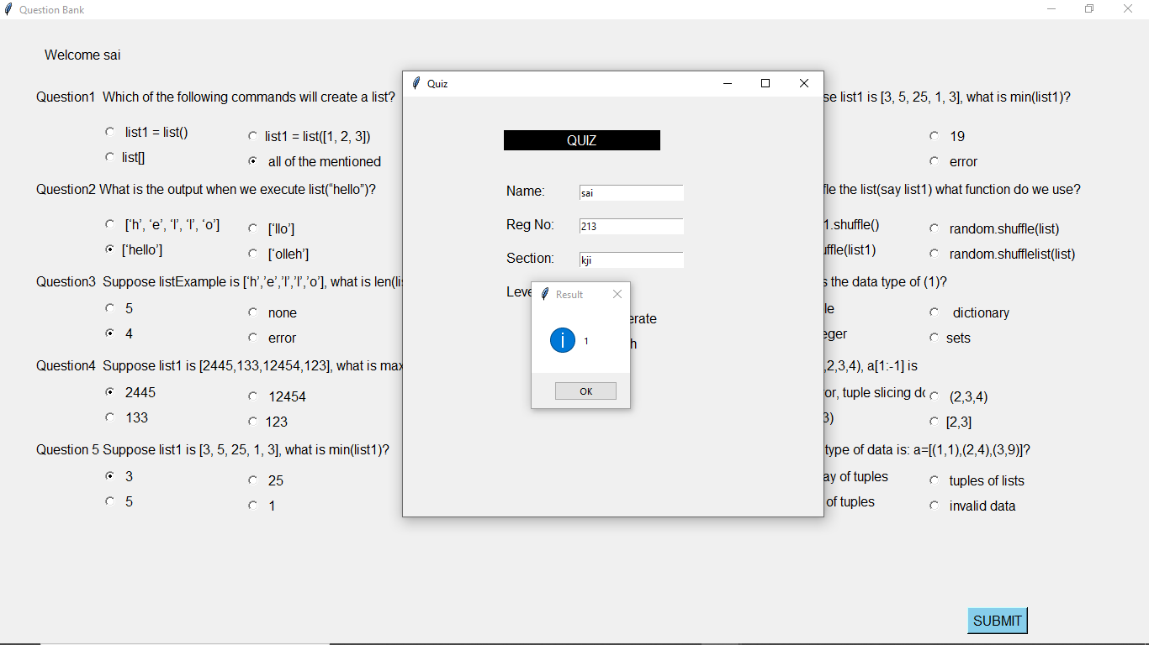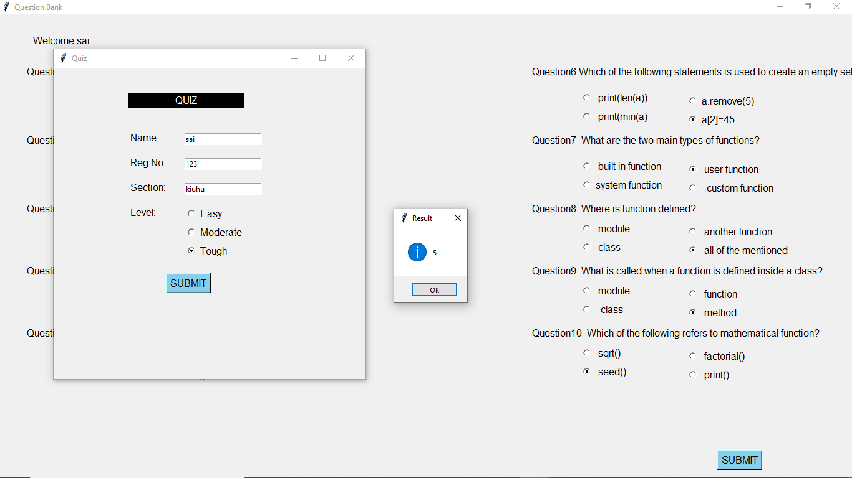

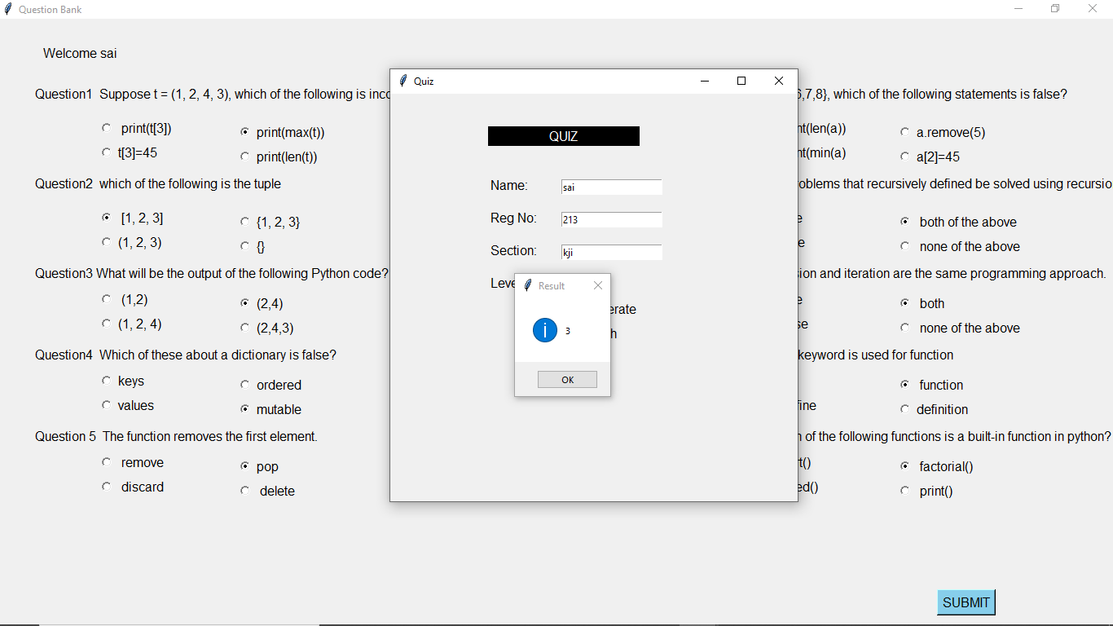

**WORK DIVISION:**

Roll No. 21

Did coding task.

Roll No. 13

Did Test Cases and helped some part in report.

Roll No. 09

Did necessary improvement in coding.

Roll No. 14

Prepared report.

**REFERENCE:**

[www.google.com](http://www.google.com)

[www.githhub.com](http://www.githhub.com)

**THANK YOU**